CELL-U-PHONE, INC.

GROUP 1

Dipti Muni
Tisha Alfred
Tseten Dawa
Sam Tramontana

CIS 3400
Professor. Kahanda
May 7th, 2003



User’s Guide

Welcome to Cell-U-Phone, Inc. customer database.
We are an authorized dealer for T-Mobile. Our customer database stands behind to support and offer expertise to the employee of Cell-U-Phone, Inc.

Contents
- Purpose of database……………………………………………..3
- Database and System requirement………………………………3
- Getting started……………………………………………………3
- Selecting from Main Menu……………….……………………..4
- Viewing tables…………………………………………………..5
- Explaining relationship and cardinality…………………………6
- Normal forms for major…………………………………………7
- Adding an attribute using SQL…………………………………8
- Delete an attribute using SQL…………………………………..8
- Retrieve information using SQL………………………………..8
- User’s service……………………………………………………8


1. Purpose of Database:
The purpose of our customer database is to keep track of our customers, products, inventory, orders and sales. Sales are made on daily basis to customers. Orders are made according to inventory in hand. Therefore, this user-friendly database that we build will be used by the employees of Cell-U-Phone to retrieve, update and enter information of the customers.

2. Data base and systems requirement:
- Microsoft Access 2000
- Windows 95 or better

3. Getting started….Please follow step by step:
- Turn on the computer.
- Click on start button in the task bar.
- Go to Programs.
- Go to Microsoft Access 2000.
- Click on button that says “Open existing file.”
- Click O.K.
- Open dialog box appears.
- Select “My document” from look in drop down list.
- Select “Cell-U-Phone.”
- The Main Menu appears.
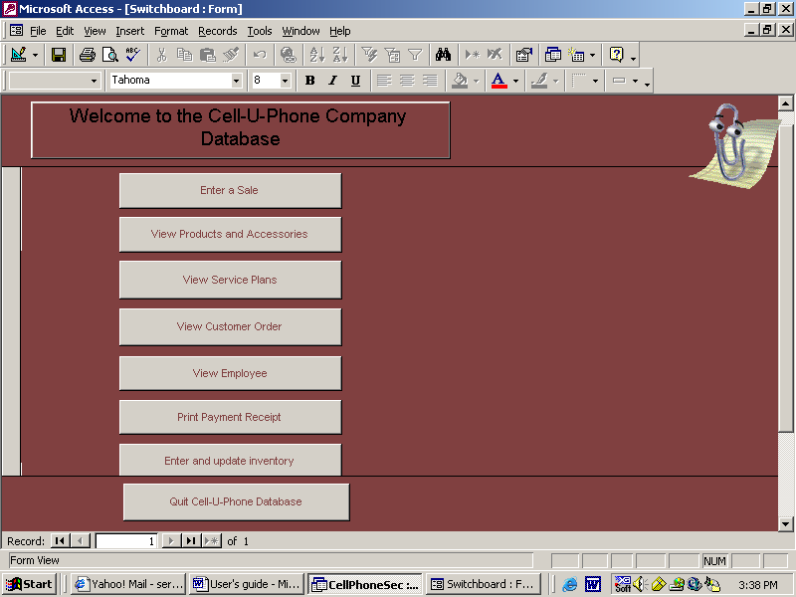
4. Selecting from Menu:
Menu:
- Enter a sale
- View Products and Accessories
- View service plans
- View Customer Order
- View Employee
- Print Payment Receipt
- Enter and update inventory
- View and Print contract
- Quit Cell-U-Phone Database

5. View Tables:
Entities and its attributes

Customer (CustomerSSN, LName, FName, BirthDate, DriverLicenseNo, Street, City, State, Zip, HomePhone)

Phone (Manufacturer, PhoneName, Type, SalePrice)

Order (CustomerSSN, CellPhone, IMEINo/Barcode, Manufacturer, PhoneName, PlanName, PhoneAmount, AccessoryAmt, OrderDate, ContractTime, BillingCycle, EmployeeSSN, InvoiceNo, Accessories, Returned)

Employee (EmployeeSSN, LName, FName, Street, City, State, Zip, HomePhone, Title, Memo)

Service (PlanName, PlanPrice, Details)

Payment (InvoiceNo, CustomerSSN, CellPhone, PaymentAmt, PaymentDate, Cash, CreditCard)

PaymentMethod (CreditCardNo, NameOnCard, ExpDate, CreditCardType, InvoiceNo)

Inventory (IMEINo/Barcode, PhoneName, OrderPrice, UnitsOnHand, UnitReceived, UnitSold)

Accessories (Manufacturer, PhoneName, Accessory, AccessoryAmt)

All the underlined attributes are the primary keys* of that entity.

. Explaining Relationship:

Used Chen’s Model to show the E-R Diagram.
Cardinalities involved are:
One to One
One to Many
Many to One

It is emphasized at the next page.

7. Normal Forms:

Normalization is a process for assigning attributes to entities in such a way that data redundancies are reduced or eliminated. Normal Form has many stages but we have explained the first 4 stages:

First Normal Form (1NF)
A relation is in a 1NF if it meets the below defination:
i Each column value must be a single value only.
ii All values for a given column must be of the same type.
iii Each column name must be unique.
iv The order of columns and rows is insignificant.
V No two rows in a relation can be identical.

Example from our entity:
Customer (CustomerSSN, LName, FName, BirthDate, DriverLicenseNo, Street, City, State, Zip, HomePhone)

Second Normal Form (2NF)
A relation is in 2NF if it is in 1NF and all of its non-key attributes are dependent on all of the keys.

Example from our entity:
Customer (CustomerSSN, LName, FName, BirthDate, DriverLicenseNo, Street, City, State, Zip, HomePhone)

Third Normal Form (3NF)
A relation is in 3NF if it is in 2NF and it contains no transitive dependencies.

Example from our entity:
Employee, Payment Method, Order, Customer and Payment Table fall into 3NF.

Boyce-Codd Normal Form (BCNF)
A relation is in BCNF if it is in 3NF and if every determinant in the table is a Candidate key.

Example:
Order, Customer and Payment entities fall into the BCNF.

Queries

8. Adding attribute:
To add an attribute to any table use the below command
ALTER TABLE Table name ADD attribute name datatype;
Example:
ALTER TABLE Employee ADD WorkPhone number;

9. Delete an attribute:
To drop or delete an attribute of any table use the below command
ALTER TABLE Table name DROP attribute name;
Example:
ALTER TABLE Employee DROP WorkPhone;

10. Retrieve information:
To retrieve information use the below command
SELECT columns
FROM tables
WHERE conditions, can be combined by logical operators such as =, >, < etc
GROUP BY if you need to put similar values together.
ORDER BY sorting the columns, default setting is by ascending order.

Example:
Employee (EmployeeSSN, LName, FName, Street, City, State, Zip, HomePhone, Title, Memo, InventoryNo)

SELECT Employee SSN, LName, FName
FROM Employee
WHERE LName = “Lana”
ORDER BY LName DESC

Can use * in the SELECT command to view all the Employee table

Example:
SELECT *

11. User’s service:

Thank you for using Cell-U-Phone Database. For further information and assistance, please call us at (718) 555-5555.

